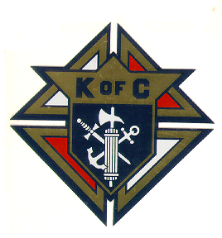
Knights of Columbus
ST. Jude Council # 4313
Coventry, CT

Council Apparel Order Form

Name: _____________________________________________________
Address: _____________________________________________________
City: _________________________________ST: __ Zip Code: ______

Check: __ Cash: __ Date: ____________ Date Arrived: _______________
Telephone/Cell Number: ________________________
Name on merchandise: _________________
Please check size below (except for hat):
Small __ Medium __ Large __ Extra Large __ 2XL __ Other _______

Sizes above 2XL, add $ 2.00 per size, per item

Qty Price Each Amount
___ Navy Blue short sleeve Polo shirt $23.00 $________
(Knights of Columbus Emblem,
St. Jude Council 4313, Coventry, CT, name)
___ Navy cotton twill hat (adjustable) $10.00 $________
(Knights of Columbus Emblem)
___ Navy pro-satin nylon baseball jacket $55.00 $________
w/gold & white stripes w/quilt lining
(Knights of Columbus Emblem,
St. Jude Council 4313, Coventry, CT, name)
(Back of jacket
the words Knights of Columbus arched over the
words Coventry CT in middle of jacket and words
St. Jude Council 4313 arched under the middle words
___ Navy Three Season jacket $55.00 $_______
w/nylon shell & fleece lining
(Knights of Columbus Emblem,
St. Jude Council 4313, Coventry, CT, name)
Nothing on back of jacket

Total Amount (Payment due at time of order) $________
Make Checks payable to: Norman Landry

